**Project Submission**

**Necessary Steps**

**Course title:** Software development project-2

**Course no:** CSE 3200

**Submitted To**

Rizoan Toufiq

Assistant Professor

Department of Computer Science and Engineering,

RUET, Rajshahi.

**Submitted by**

S.M.Shovan

Roll: 133001

3rd year even semester

Section ‘A’

CSE dept.

**Project Title:** Building Weather Station using Raspberry Pi.

**Required apparatus:**

* Raspberry pi 3B Raspbian OS.
* DHT2302 (Digital Humidity and Temperature Sensor), wired version of DHT22.
* One 4.7Kohm.
* Breadboard.
* Ethernet cable for remote hosting.
* Jumper wire.
* Power source 5v-2.1A.
* Micro SD card.

**Library used:**

* Adafruit library. (https://github.com/adafruit/Adafruit_Python_DHT.git)

**Steps**

**Step 1:** We need to setupRaspbperry Pi and connect to a computer as a remote host using VNCviewer or Putty or connect Raspberry Pi to an additional display using the HDMI cable.

**Step 2: Circuit Setup:**

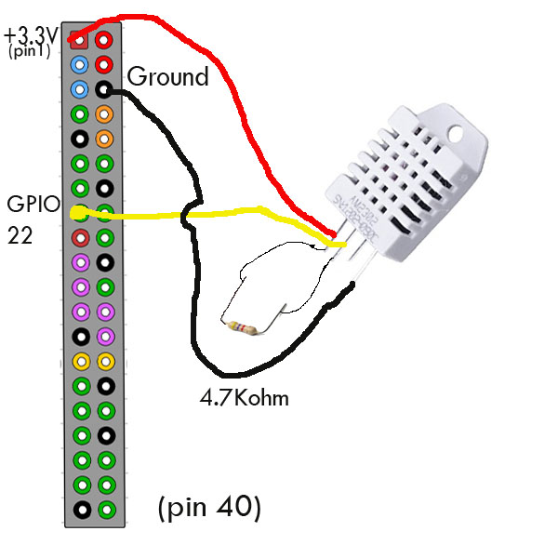

Fig: Connection setup between Raspberry Pi & DHT2302

**Step 3:**

We need to install python compiler. (All the commands must run on terminal)

* **sudo apt-get install build-essential python-dev python-openssl**

**Step 4:**

**We need to place Adafruit library to /home/pi from folder named “library” And install.**

1. **cd Adafruit_Python_DHT**
2. **sudo python setup.py install**

**Step 5:**

**Then we need to install MySQL**

1. **sudo apt-get install mysql-server python-mysqldb**

**Step 6:**

**Now we need to setup database and create a user name “logger” and set password “password”.**

1. **CREATE DATABASE temperatures;**
2. **USE temperatures;**
3. **CREATE USER 'logger'@'localhost' IDENTIFIED BY 'password';**
4. **GRANT ALL PRIVILEGES ON temperatures.* TO 'logger'@'localhost';**
5. **FLUSH PRIVILEGES;**

**Step 7:**

**After then, we need to create table with relevant attributes.**

1. **USE temperatures;**
2. **CREATE TABLE temperaturedata (dateandtime DATETIME, sensor VARCHAR(32), temperature DOUBLE, humidity DOUBLE);**

**Step 8:**

**Now we need to place the contents of “Python-Codes” folder to /home/pi.**

**Step 10:**

**Then we need to schedule to python codes for running every minute.**

1. **crontab –e**
2. **\*/1**** python /home/pi/DHT22-TemperatureLogger/DHT22logger.py**

Step 11:

Now we need apache for creating server.

* **sudo apt-get install apache2 php5 libapache2-mod-php5 php5-mysql php5-cli –y**
* **sudo /etc/init.d/apache2 restart**

Step 12:

Now we need to place the contents of “web page files” to the location **/var/www/html/.**

Super user privilege is necessary for placing.

Step 13:

For viewing the webpage we need to type the **ip address** of the raspberry pi in host machine or simply “**localhost”** in the server machine.

A webpage will pop up with relevant information.

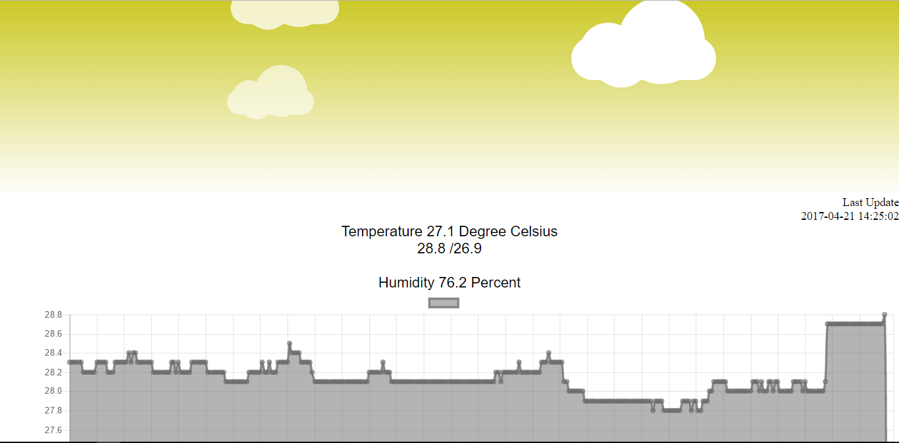

Fig: webpage.